Experiment No. 9

Aim : Study and Installation of Weka AI tool
Name : Yash Ravindra Gawande
Roll No. : 37
Sec : 3A
Subject : ET - 2

Theory:

What is Weka?

Weka (Waikato Environment for Knowledge Analysis) is a popular suite of machine learning software written in Java. It is developed by the University of Waikato, New Zealand.

🔹 Key Features:
- GUI-based and user-friendly
- Supports various machine learning
algorithms (classification, regression, clustering)
- Data pre-processing tools
- Visualization tools
- Supports scripting and Java API for developers
🔹 Applications:
- Academic research
- Data mining projects
- Rapid prototyping of ML models
- Teaching and learning machine learning concepts

🔹 Core Components:
- Explorer – Main GUI for data analysis
- Experimenter – For running experiments and comparing algorithms
- Knowledge Flow – Visual pipeline-style interface for data flow
- Simple CLI – Command-line interface
Installation of Weka:
Step-by-step Instructions:
🔸 For Windows:
- Go_to_Official_Website
➤https://www.cs.waikato.ac.nz/ml/weka/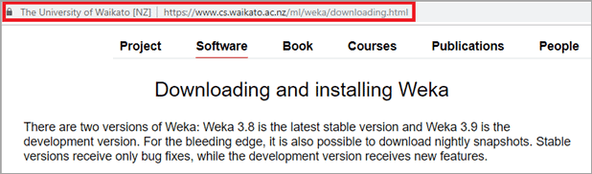
- Click on the "Download" tab
- Choose Windows Installer (.exe file)
- Download_and_run_the_installer
➤ Follow the setup wizard steps (Next → Install → Finish)
- Launch Weka from the Start Menu or desktop icon.

Running Your First Machine Learning Model in Weka:
🔹 Step 1: Open Weka:
- After installation, launch the Weka GUI Chooser.

🔹 Step 2: Open "Explorer":
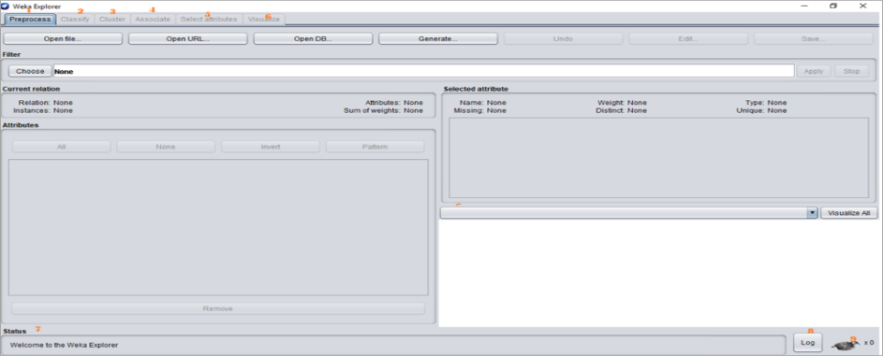
🔹 Step 3: Load a Dataset:
- Click Open File
- Navigate to: /data/iris.arff
- This is a sample dataset with flower measurements.
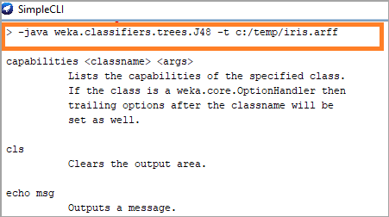
🔹 Step 4: Choose a Classifier:
- Go to the "Classify" tab
- Click "Choose" → trees → select J48 (decision tree)
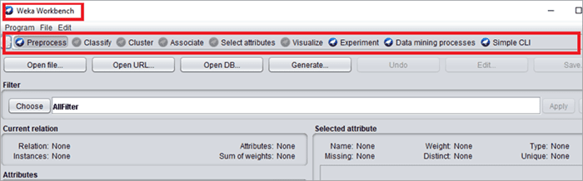
🔹 Step 5: Click "Start":
- Weka will train the model and show results like:
  - Accuracy
  - Confusion Matrix
  - Precision, Recall, F-measure

Advantages of Using Weka:
- ✅ Easy to use, even for beginners
- ✅ Excellent for quick testing and prototyping
- ✅ Includes many algorithms without needing to code
- ✅ Good for educational and research purposes
Limitations of Weka:
- ❌ Not suitable for very large datasets (in-memory only)
- ❌ Limited support for deep learning
- ❌ GUI can feel outdated

Conclusion:
- Weka is a valuable tool for anyone learning or experimenting with machine learning. It simplifies data pre-processing, model training, and evaluation through its user-friendly interface. Though it may not be suited for large-scale production systems, it is ideal for teaching, research, and prototyping.

